 | Customer Insights · Sprint Review
New insights — Word Add-In in-app questionnaire
Quantitative summary for PMs · Lime Survey questionnaire · n = 66 respondents · 24 Jul 2026

66  Responses in batch | 30  With feedback | 21  Insights taken forward | 5  New records (492–496) | 16  Merged into existing | 10  Bugs logged | 3  Contradictions flagged
Database now 377 records · 492–496 created in this study Bug list 12 → 22 rows (8 dropped defects + 2 Implemented≠resolved cross-refs) 3 contradictions flagged: ID 254, 256, 392
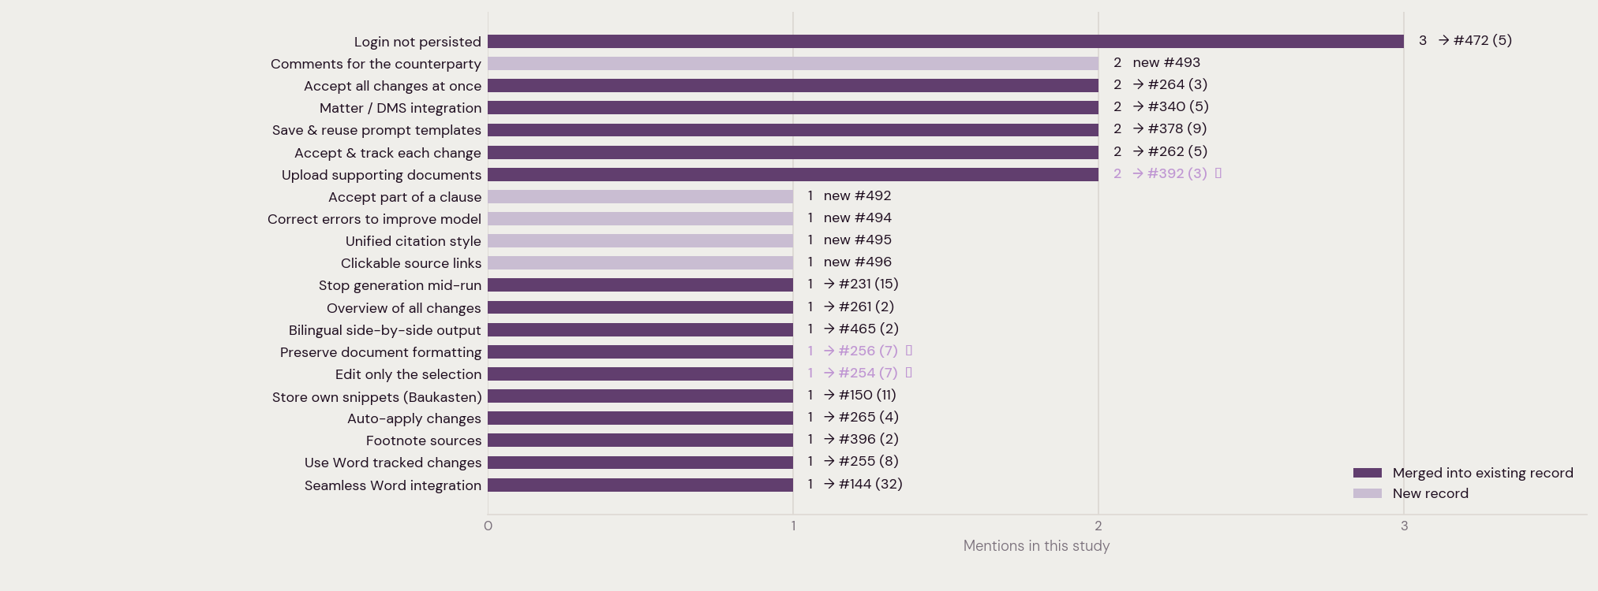
21 insights carried forward, ranked by mentions in this study. Colour shows whether each reinforced an existing record (with its new running total) or created a new record (#492–496). ⚠ marks an Implemented ≠ resolved or intra-batch contradiction. The single most-reported item — the non-functional send button (9 mentions) — is a defect tracked in the bug list, not shown here.

